**Task 1**

* Demonstrate minimum 15 basic Git command with explanation and screenshot.

1. **git init** :- The git init command creates a new Git repository.



1. **git status** :- The git status command displays the state of the working directory and the staging area.

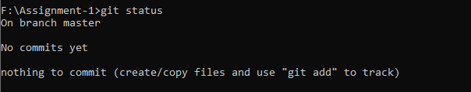

1. **git clone** :- git clone is primarily used to point to an existing repo and make a clone or copy of that repo at in a new directory, at another location. The original repository can be located on the local filesystem or on remote machine accessible supported protocols. The git clone command copies an existing Git repository.

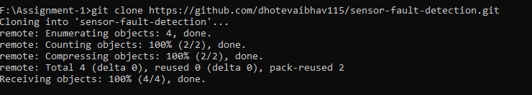

1. **git add :-** The git add command adds a change in the working directory to the staging area. It tells Git that you want to include updates to a particular file in the next commit.

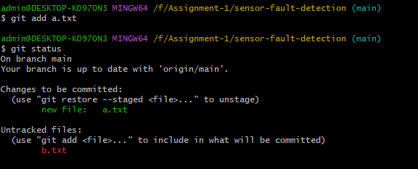

1. **git commit –m “massage”:-** The "commit" command is used to save your changes to the local repository.

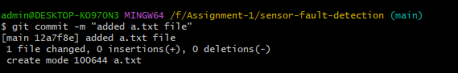

1. git config --list :- The **git config** command is a convenience function that is used to set Git configuration values on a global or local project level.

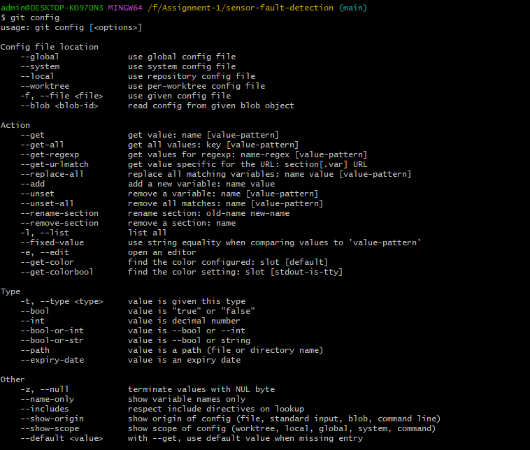

1. **Git config –list** :- The git config list command will show all Git config properties throughout all of the variously scoped Git files.

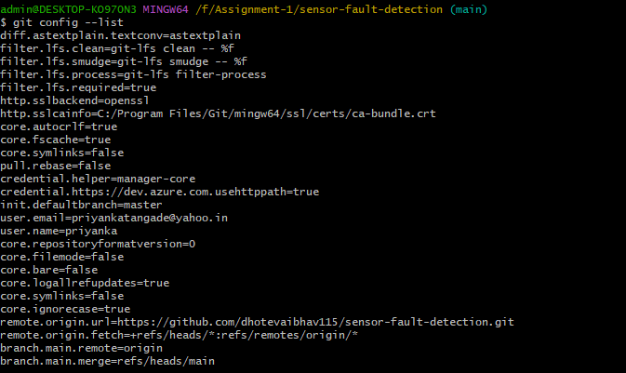

1. **git config --global user.name "vaibhav dhote"** :-  This will configure your ***Username*** in Git Bash.



1. **git config --global user.email xyz@gmail.com:-**This will configure your mail id



1. **git config --global user.password "password"** – This will configure your password



1. **git branch**:- show on which branch you are currently working on



1. **git branch devlop** :- It will create new branch

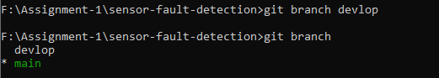

1. **git checkout devlop** :- it will help to navigate between the branches created by git branch .



1. **git push** :- It is used to upload local repository content to a remote repository. Pushing is how you transfer commits from your local repository to a remote repo.



1. **git pull** :- The git pull command is used to fetch and download content from a remote repository and immediately update the local repository to match that content.



1. **git stash** :- The git stash command takes your uncommitted changes (both staged and unstaged), saves them away for later use, and then reverts them from your working copy.



### Task 2

* Consider that your want to start an open-source project in your organization. Perform all the standard operation to create a repository with minimal permision for all the users. It should contain.

1. **Proper open source structure**

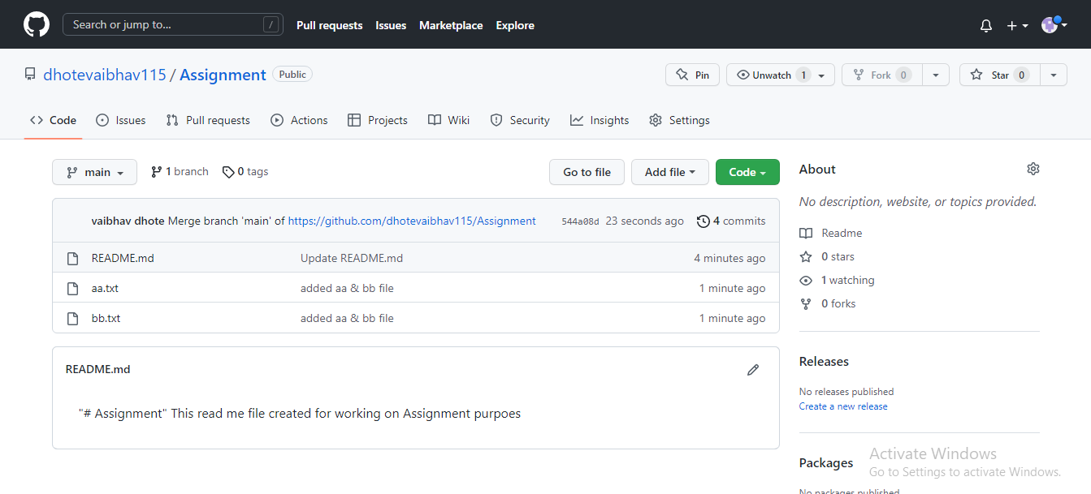

1. **Proper Readme**

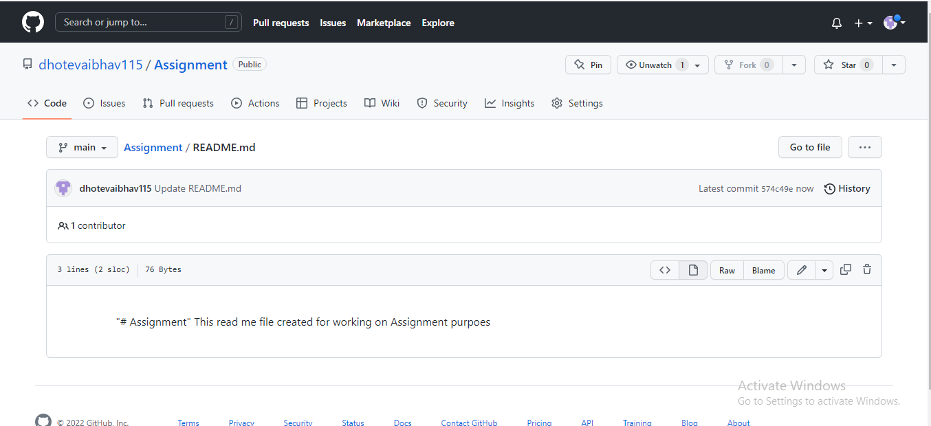

1. **Add 2 collaborator**

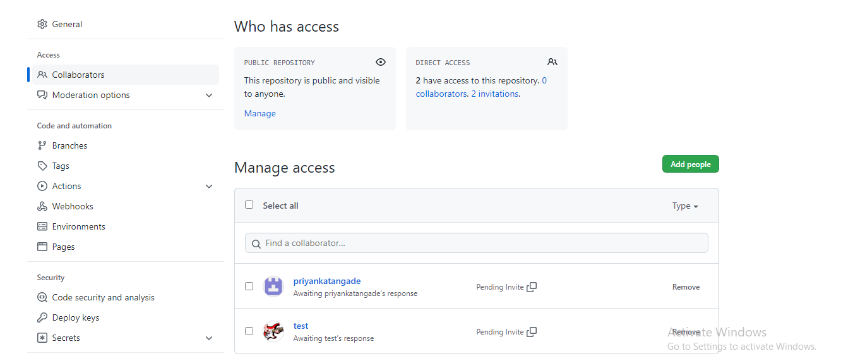

1. **Host GitHub Pages using settings (Designed to host your personal, organization, or project pages from a GitHub repository)**

Link - https://dhotevaibhav115.github.io/GitHub-Pages.github.io/

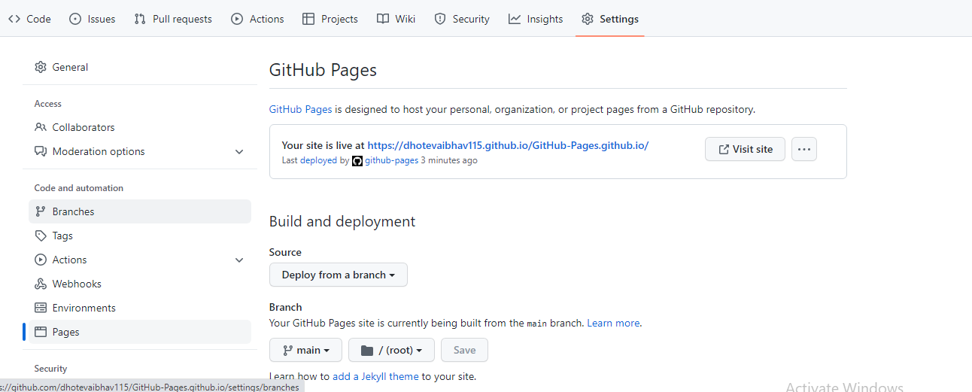

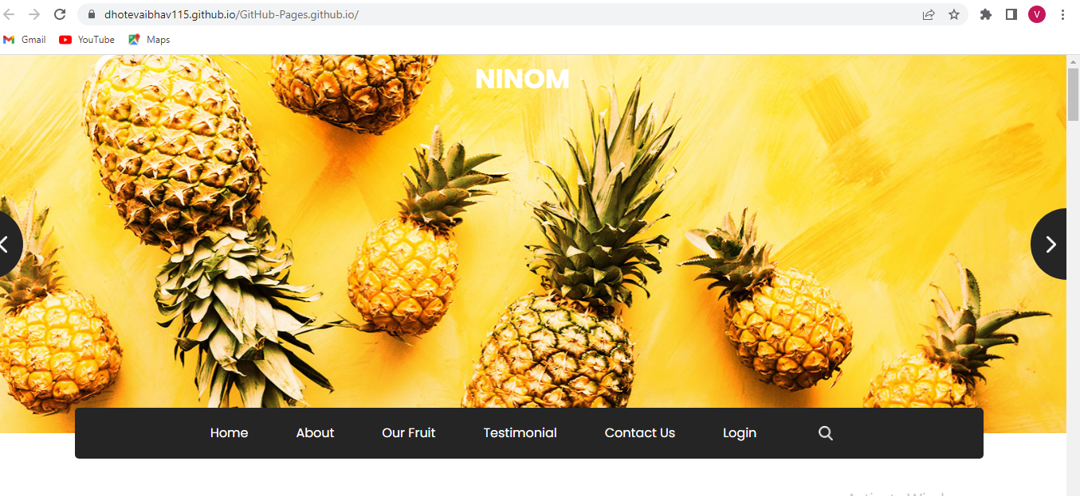

### Task 3

1. **Create a Issue in your github repository.**

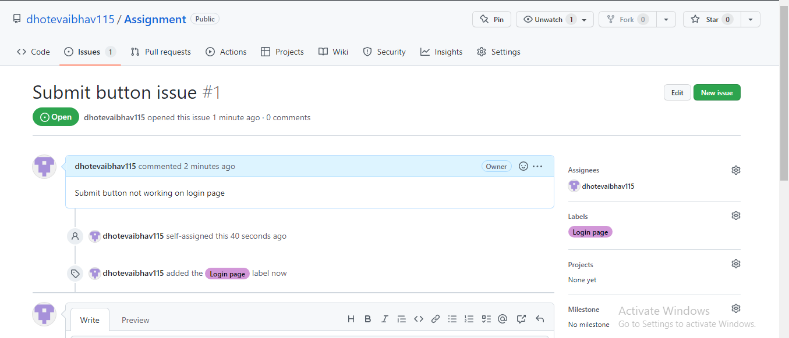

1. **Raise a pull request**.

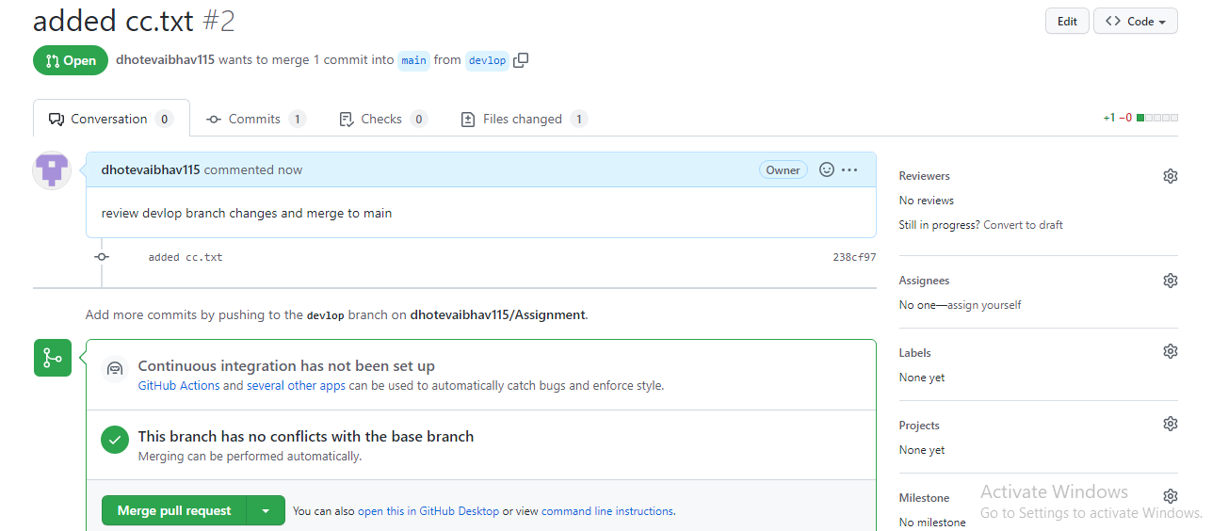

1. **Merge A pull request.**

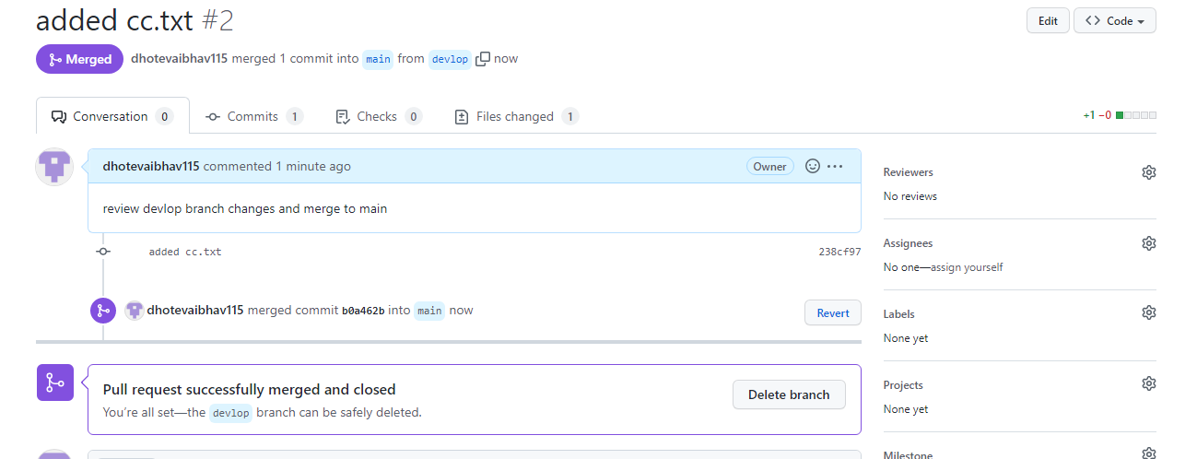

1. **Reject a pull request with proper comments.**

Not able to find **Reject** option, kindly suggest

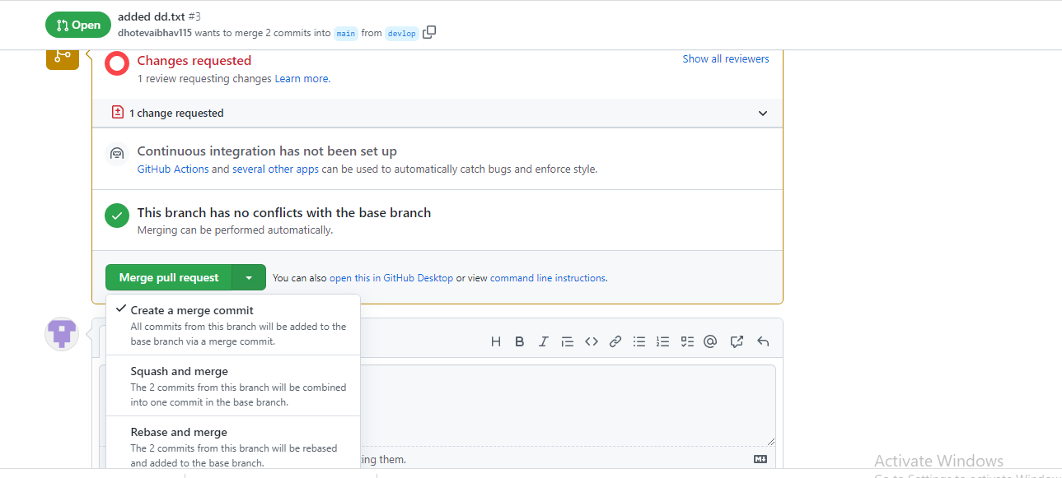

1. **Add a Dependabot alerts in your github.(for above cases)**

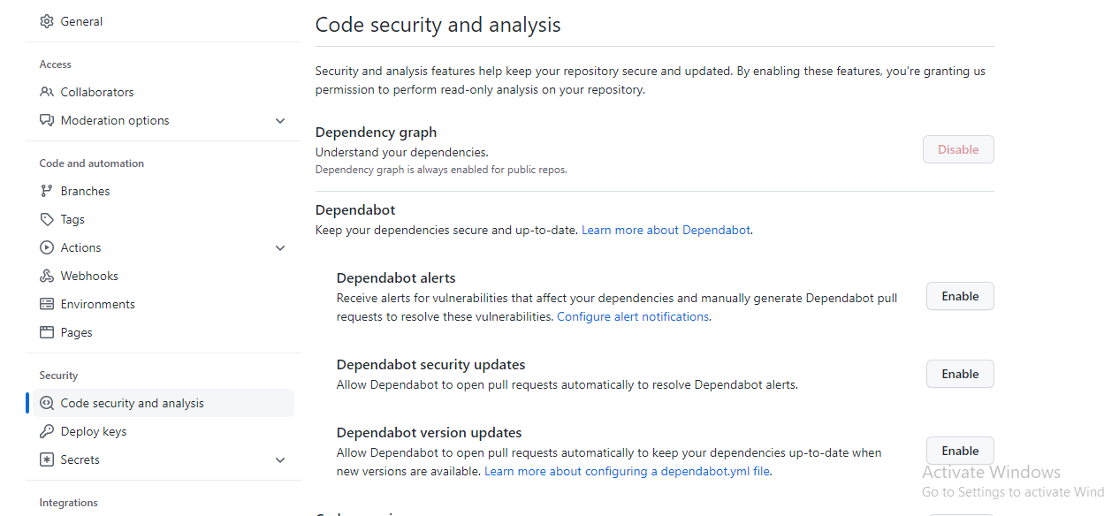

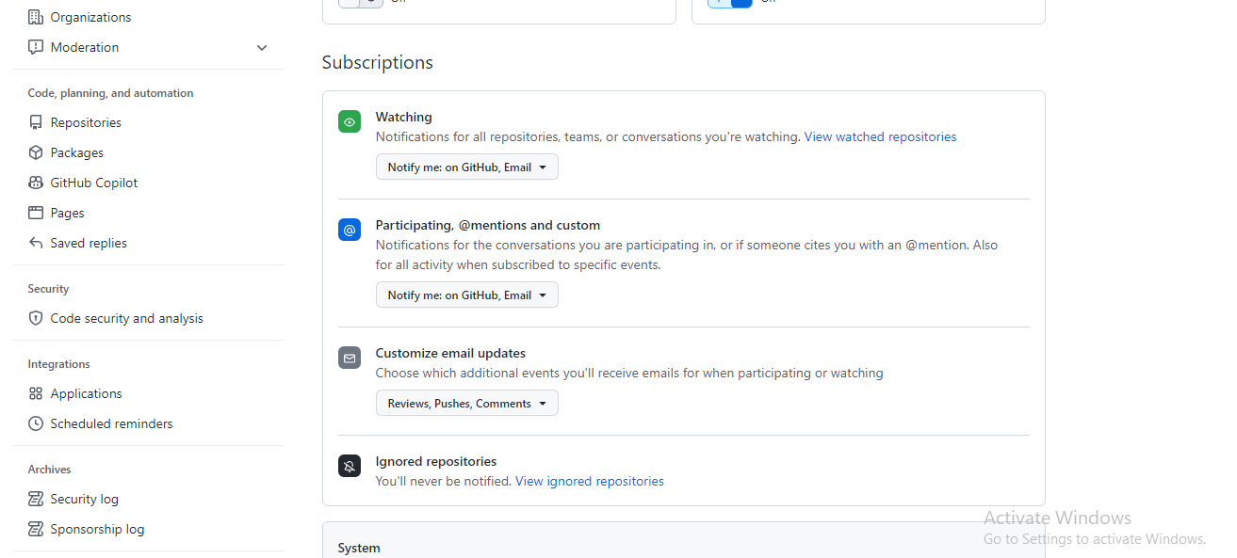

1. **Stash changes**



1. **Create a release your package**

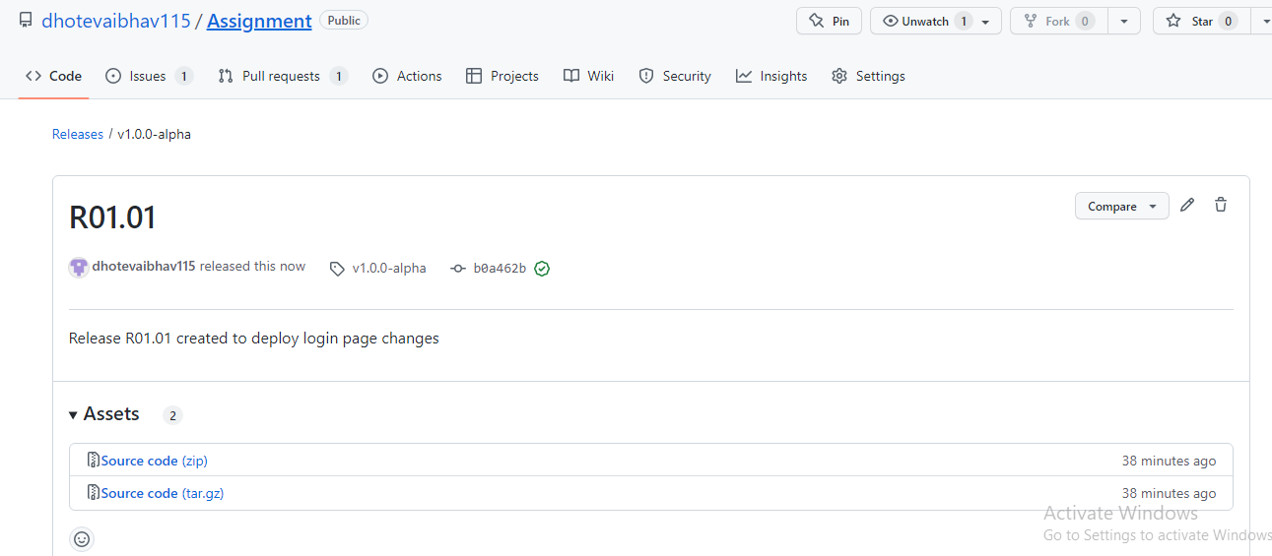

1. **Setup a Projects Board for your project.**

